Domeno (feat. Pierre Bouvier) – Alleys

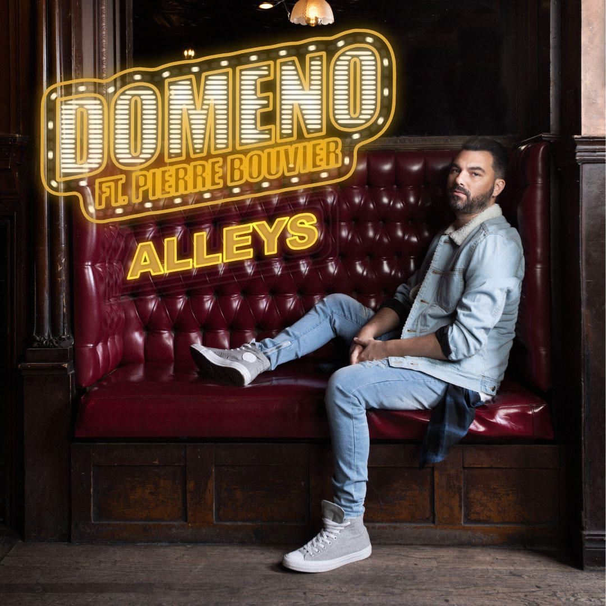

On the international scene, no DJ from Quebec knows a rise as lightning as Domeno. The Montreal artist makes the crowds dance from New York to Amsterdam, from Ibiza to Miami. His pieces are played by the biggest names in the electro scene like Hardwell, David Guetta, Afrojack and Martin Garrix. In Quebec, his huge success "Lies" won the radio waves for 47 consecutive weeks and became the second most-played song on radio in 2018. In 2019, the ingenious songwriter and passionate producer, Domeno decided to launch "Elisa Recordings", A brand new Electronic Dance Music label, in collaboration with his manager (Patrice Laflamme) and Coyote Records (Rafael Perez), on which will appear his next musical creations.

The song: Alleys

After the success of "Lies" in Quebec, Domino decided to take his time to come back in force with a single to be released all across Canada. During his absence, he composed the theme song of Quebec’s new reality show “XOXO TV”, in addition to producing the debut album of "Zagata" (Coyote Records / Universal Canada) especially known for his song “Lies” with Domeno.

For "Alleys", Domeno decided to surround himself with the cream of the crop.
- The Swaggernautz duo who have written for Troye Sivan, Pitbull, Kaskade, etc., and who have more than 60 Top 20 records all over the world.
- Andrew Allen who wrote for Carly Rae Jepsen, Meghan Trainor, Cody Simpson, etc.
- Richard Beynon who composed for Flo Rida, Zara Larsson, Jonathan Roy, etc.
- Pierre Bouvier (Simple Plan) on the vocals.
STATS//
Instagram: + 8,858 followers
Facebook: + 29,298 likes / followers
Youtube: + views
Spotify: + 7 million streams

HIGHLIGHTS DOMENO//
- "Lies" has been 47 consecutive weeks in the Top10 of the Top100 BDS Adisq (2018)
- "Lies" is the 2nd most played song in Quebec in 2018 (BDS)
- "Lies" was # 1 in the Top25 BDS Adult Contemporary
- "Lies" was # 2 in the Adisq BDS Top100
- "Lies" was # 10 in the Canadian Mediabase AC Chart
- "Lies" has had several synchro, especially for the “Montreal en Lumière 2018”, Revolution, XOXO Télé and Le Jeu.
- He composed the theme song of XOXO Télé
- He played at the "Ultra Music Festival" in 2015
- He replaced the legendary "Steve Angello" (Swedish house mafia) at Île Sonic 2018

HIGHLIGHTS PIERRE BOUVIER//
- Lead singer of SIMPLE PLAN
- 8 times Platinum in Canada with his albums
- 3 times Platinum in USA with his albums
- 3 times Platinum in Australia with his albums
- 2 times Silver in UK with his albums
- Radio Canada/La Presse Awards
- 2013 Nominated for Arts and Entertainment Award
- Dahsyatnya Awards
- 2013 Nominated for Outstanding Guest Star
- CASBY Awards
- 2002 Won CASBY Award
- Juno Awards
- 2012 Won Allan Waters Humanitarian Award
- 2009 Nominated for Juno Award
- 2009 Nominated for Juno Award (for the group itself)
- 2006 Won Juno Fan Choice Award
- 2005 Nominated for Juno Award
- 2005 Nominated for Juno Award
- 2005 Nominated for Juno Award
- Kerrang! Awards
- 2008 Nominated for Kerrang! Award
- MTV Asia Awards
- 2006 Nominated for Favourite Pop Act
- MTV Europe Music Awards
- 2014 Nominated for MTV Europe Music Award (Best World Stage- WS Monterrey)^{[67]}
- MTV Video Music Awards
- 2004 Nominated for MTV Video Music Award
- 2003 Nominated for MTV Video Music Award
- MuchMusic Video Awards
- 2012 Nominated for MuchMusic Video Award (Best International Video by a Canadian)
- 2012 Nominated for MuchMusic Video Award (UR FAVE VIDEO)
- 2011 Nominated for MuchMusic Video Award
- 2009 Won MuchMusic Video Award
- 2008 Won MuchMusic Video Award
- 2008 Nominated for MuchMusic Video Award
- 2008 Nominated for MuchMusic Video Award
- 2006 Won MuchMusic Video Award
- 2006 Nominated for MuchMusic Video Award
- 2006 Nominated for MuchMusic Video Award
- 2005 Won MuchMusic Video Award
- 2005 Nominated for MuchMusic Video Award
- 2005 Nominated for MuchMusic Video Award
- 2004 Won MuchMusic Video Award
- 2003 Won MuchMusic Video Award
- NRJ Music Awards
- 2012 Won NRJ Music Award
- 2007 Nominated for NRJ Music Award
- Teen Choice Awards
- 2008 Nominated for Teen Choice Award
- 2005 Won Teen Choice Award
- ADISQ
- 2006 Won Artiste québécois s'étant le plus illustré hors Québec
- 2006 Won Album de l'année – Anglophone

MARKETING //
- There will be a teaser countdown for 7 days on Domeno's social networks.
- A statement will announce the release of the song.
- A publication on the social networks of Domeno and Kain will be made with a SmartUrl redirecting on the various platforms
- Sending a newsletter to announce the release
- A button '' follow this artist on Spotify '' will be added to the newsletter
- Publications will be sponsored on Facebook and Instagram from the pages of Domeno and Pierre Bouvier
- Radio tracking
- Press relations
- Radio tour
- Mention of Spotify and playlists in sponsored publications
- Mention of Apple Music, Amazon, Deezer on Facebook / Instagram when the song is in playlists
- Sharing the album on Spotify directly in the instagram stories of Domeno and Pierre Bouvier

KEY PLAYLISTS SPOTIFY//
Canada / USA / Australia / UK Playlists (Simple Plan are very popular over there).
Tropical House // 438,000 + streams for “Lies”
Electro Chill // 87,000 + streams for “Lies”
Mint Canada // 80,000 + streams for “Lies”
Dance Favorites // 17,000+ streams for “Lies”
Pop all day
Hot Hits Canada
Bangers
Mint
Dance Party
Chill tracks
DancePop
Dance Favorites
All day dance party
Any other relevant dance / edm playlists

MOOD //
Chill
Folk
Dance
EDM
Training
Party
Fun
Energetic
Happy

MANAGEMENT
Patrice Laflamme | patrice@mamasboymusic.com
+1 (438) 882-8259

INFOS //
Artist : Domeno
Feature : Pierre Bouvier
Title : Alleys
Durée : 3 :28
CanCon : Yes
Authors : Tat Tong, Jovany Javier, Andrew Allen, Pierre Bouvier
Composer : Domenic Pandolfo, Richard Beynon, Tomas Shaw, Ryan Henderson
Producer : Domenic Pandolfo
Co-producer : Richard Beynon
Label : Elisa Recordings
Publisher : Sony ATV, Universal, Musicor
Distributer : UMC
ISRC Code : CA-DIM-19-00007

