PRESS RELEASE for immediate distribution

Roch Voisine launches
a new, original Christmas song:

My First Christmas Tree

ALSO AVAILABLE IN FRENCH

Montréal, November 20, 2018 ● Almost 20 years after the launch of L’album de Noël in 2000, Roch Voisine is doing up holiday music in style once again with a brand-new, original song: My First Christmas Tree. Inspired by his childhood memories of magical Christmases and snowy winters, the singer-songwriter wrote the song, filled with wonder and tender nostalgia, with Jeff Smallwood.
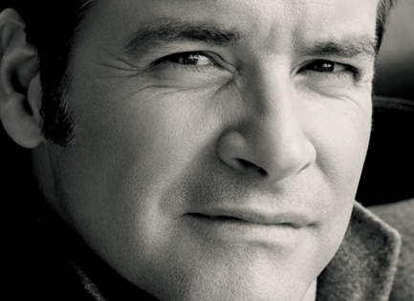
“I have always been a major fan of Christmas. At home, in my grandparents’ house, it would last a week! With lots of people, heaps of food, incredible decorations, and snow, so much snow! And of course, music. Christmas classics played nonstop at home; and, at 7, I started to sing at the traditional midnight mass. I was fortunate to experience such beautiful family holidays; they were spectacular. The smells, colours, laughter, songs, snowstorms; I have so many treasured memories of my childhood Christmases. Jeff Smallwood and I wrote My First Christmas Tree when we were both new fathers. And here it is today, 14 years later!” Roch Voisine.

The song was produced by Jay Lefebvre, and we can thank his little 5-year-old Mélodie for the delightful tree that illustrates the single! Jean-Sébastien Baciu and Roch Voisine co-produced. Initially written in English, the French version was created by Christophe Trépanier, Jay Lefebvre and Roch Voisine. The two versions of the song – French (Mon premier sapin blanc) and English (My First Christmas tree) – are available on all digital platforms. You can download them here. http://torpille.ca/2018/11/roch-voisine-my-first-christmas-tree/

The singer will interpret the French version Mon premier sapin blanc during two performances of Noël symphonique at the Maison symphonique on December 1. As well, pursuing his successful national and international career, Roch Voisine will tour several Canadian and European cities until March 2019 with Acoustic, and appear at the Grand Rex in Paris February 15. Then, in May 2019, he’ll happily join his friends Garou and Corneille for the presentation, both here and in France, of the second version of Forever Gentlemen! For more information about all the dates in his very full schedule, see ROCHVOISINE.COM.

-30-

SOURCE RV International ● PRESS RELATIONS Roy & Turner Communications, Marie-France Côté, 514 844-9678 ext. 206, mfcote@roy-turner.com ● RECORD COMPANY RV International ● RADIO PROMO Torpille Jean-Francois Blanchet and Joanick Tétreault 579 721-3212

